**One-Day Hand-on-training of BG 4th Sem Students at SKUAST-K Faculty of Agriculture Wadura-Sopore on Thursday, June 12th 2025**

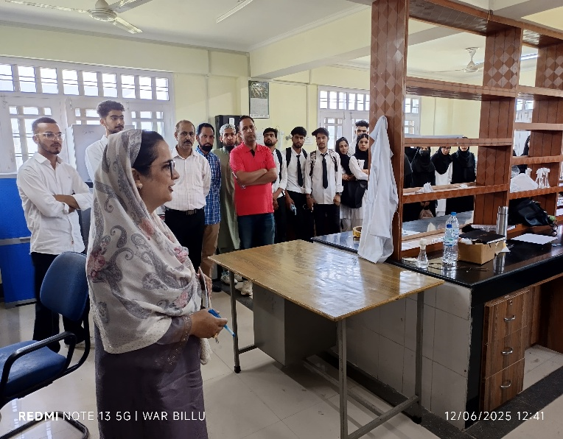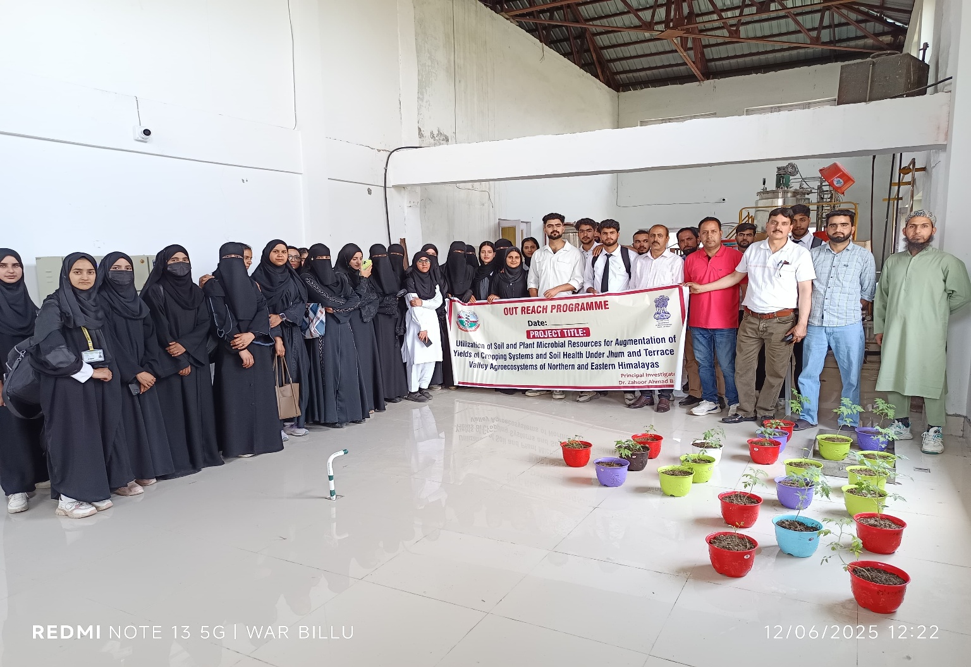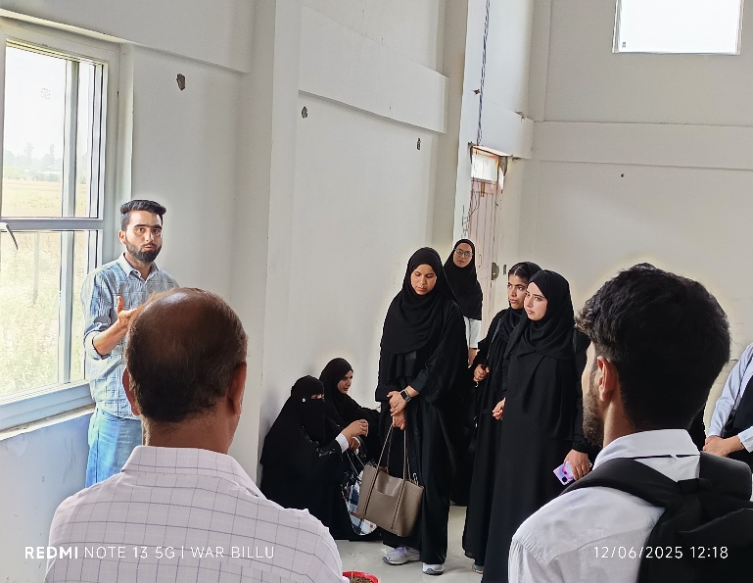50 students of B.G. 4th Semester of Botany Department along with 5 Staff members of the Department Prof. (Dr.) Zahid Hussain, HOD Botany, Prof. Zafar, S. Khan, Dr. Zahoor Ahmad, Dr. Mudasir Qadir and Mr. Mohammad Akbar were deputed to Faculty os Agriculture SKUAST-K Wadura Sopore to gain first hand experience/ orientation regaring various aspects of Economic Botany, Stress physiology, and production of fertilizes. The students were demonstrated with the modern equipments used in the field of Agriclture and Botanical Sciences. The students also learned about various medicinal plants of the Kashmir grown at the Campus of Agriculture College. The resource person Dt, Asha Nabi in her demonstrative lecture emphasized the importance of such training programs, as the need of the hour so that a sense of Entrepreneurship can be inculcated among the youths, besides aquatinting the students about the operation and use of various high end scientific instruments.

Dr. Dogra presented a threadbare on-field session on various breeding strategies of important food plants especially wheat.

Dr. Fazil, Research Scholar Division of Plant Physiology presented a live demonstrative session about the procedure for production of various bio-fertilizers, and the role of macro and micro nutritive on the plant health. Students also learned to diagnose deficiency symptoms of various plant nutrients in various crop plant speciess.

Dr. Tanveer A. Wani, Associate Professor, Division of Plant Pathology also talked with the students about various aspects of Stress Physiology in plants and its role in agriculture and Botany.

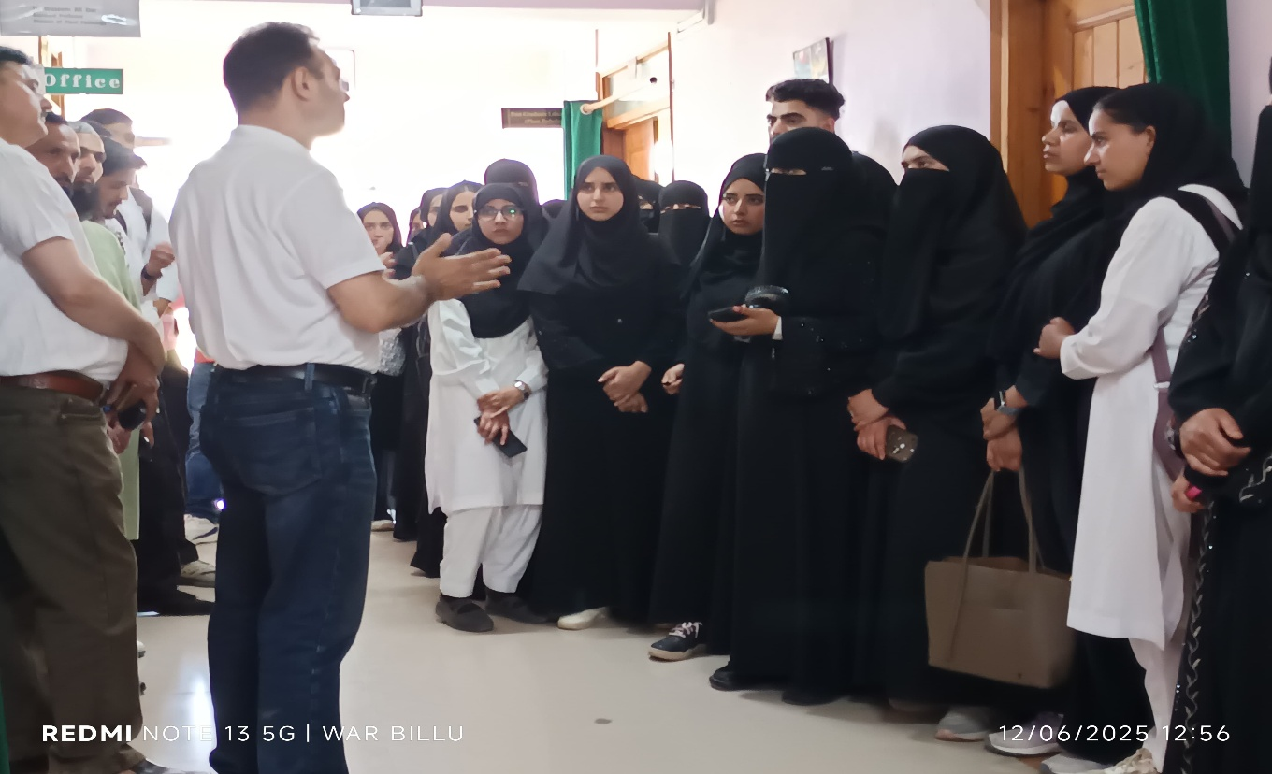Lastly Prof. D. Shakeel A. Mir, Dean Faculty of Agriculture interacted with the students and motivated them for pursuing higher studies in Agriculture and Allied sciences.

